## Imagen que contiene Icono Descripción generada automáticamenteUNIVERSIDAD AUTONOMA DE COAHUILA CENTRO DE IDIOMAS US



**4TH TEST**

LEVEL 9 KIDS

**STUDENT´S NAME: DATE: TEACHER´S NAME: WRITTEN GRADE ORAL GRADE**

**VoVcaobcaublaurlyary**

Unit 9 Test

Vocabulary

**Vocabulary**

1 Look and circle Yes or No*.*

|  |  |  |
| --- | --- | --- |
|  |  |  |
| 1 hut  Yes / No | 2 horse and cart  Yes / No | 3 straw  Yes / No |
|  |  |  |
| 4 smoke  Yes / No | 5 stairs  Yes / No | 6 jewelry  Yes / No |

     / 6

2 Choose words from the box to complete the sentences.

get go leave start study

1 They are going to                           to college next year.

2 My parents will be sad when I                           home.

3 I want to                           a job that I enjoy.

4 Children                           school when they are five years old.

5 My brother needs to                          for his math test tomorrow.

     / 5

**Grammar**

3 Read and choose A, B, or C.

**Farming in the Middle Ages**

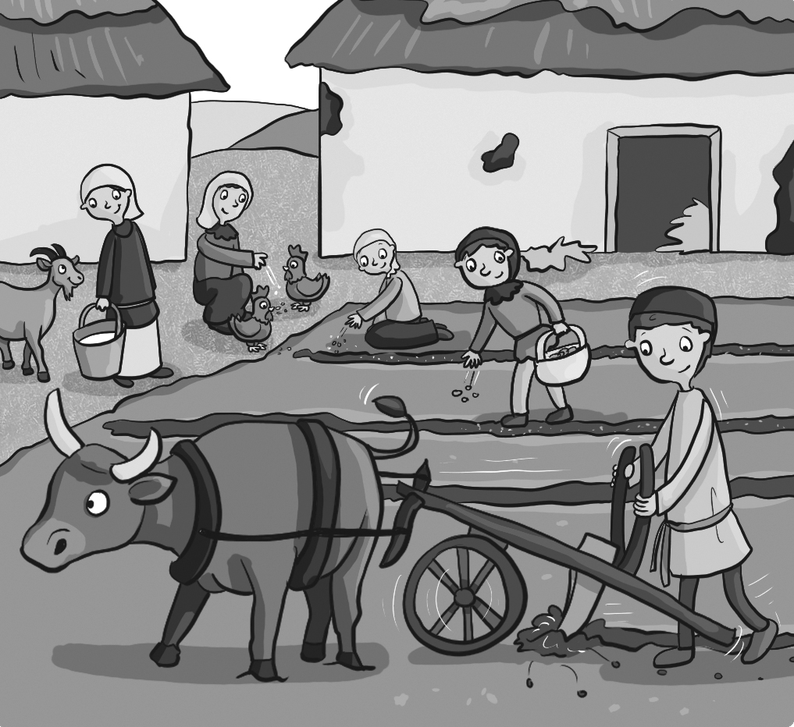

In the Middle Ages, most people 1       on farms.

They 2       vegetables in the fields. They 3       seeds

in the summer because it was too hot.

Did farmers 4       tractors in the Middle Ages? No!

They had an ox to help them in the fields.

Women and girls 5       the animals on the farm.

1 A ☐ use to work B ☐ didn’t use to work C ☐ used to work

2 A ☐ use to grow B ☐ didn’t use to grow C ☐ used to grow

3 A ☐ use to sow B ☐ didn’t sow C ☐ used to sow

4 A ☐ use to drive B ☐ didn’t use to drive C ☐ used to drive

5 A ☐ use to take care of B ☐ didn’t use to take care of C ☐ used to take care of

     / 5

4 Complete the sentences with the *-ing* or infinitive form of the verb in parentheses. If both are possible, write both.

1 I enjoy                                 (watch) movies about the past.

2 My sister decided                                 (leave) home last month to go to college.

3 My best friend just finished                                 (do) her science project.

4 David doesn’t want                                 (get) married.

5 They like                                 (send) emojis to their friends.

     / 5

**Reading**

5 Read and circle T (true) or F (false).

|  |
| --- |
| **Home          About          Contact Me**  My Amazing Aunt Alice    My Aunt Alice is an amazing person. She was born in  1978 and four years later she started school. Girls at  her school didn’t use to like science or math very  much, but Alice enjoyed studying a lot. She worked  hard at school and she was very smart. When she  was 15, she decided to study for a test to go to  college. She went to Oxford University to study  science when she was only 16. She used to visit her parents at home every weekend. After she finished studying at college, she got a job as senior science teacher at her old school. She got married to Uncle Pete in 2010 and they had two children – my cousins, Alan and Katy. Aunt Alice loves her job, and she likes helping students enjoy learning science. She doesn’t want to retire for a long time! |

1 A lot of girls liked science and math when Alice was at school. T / F

2 Alice used to study a lot at school. T / F

3 She didn’t see her parents while she was at college. T / F

4 She got a job teaching science at Oxford University. T / F

5 Alice would rather work than retire. T / F

     / 5

**Writing**

6 Think about a retired person you know. Answer the questions.

Name:

1 When was he / she born?

2 Why is he / she interesting?

3 What was an important event in his / her life?

4 What is he / she doing now?

5 Why do you like this person?

     / 5

**Listening**

9 Listen to people talk about life events. Choose A, B, or C.

1 A ☐ study for a test B ☐ go to college C ☐ start school

2 A ☐ get married B ☐ have children C ☐ get a job

3 A ☐ leave home B ☐ retire C ☐ start school

4 A ☐ go to college B ☐ get a job C ☐ leave home

5 A ☐ retire B ☐ get married C ☐ get a job

     / 5

Unit 10 Test

Vocabulary

**Vocabulary**

1 Look and write the words.

bored busy excited  scared surprised tired

|  |  |  |
| --- | --- | --- |
|  |  |  |
| 1 | 2 | 3 |
|  |  |  |
| 4 | 5 | 6 |

     / 6

2 Write the letter to make phrases.

|  |  |
| --- | --- |
| 1 put up  2 plan  3 grill  4 tell  5 build | A burgers  B a stage  C an event  D decorations  E jokes |

     / 5

|  |  |  |  |  |
| --- | --- | --- | --- | --- |
| 1 | 2 | 3 | 4 | 5 |

**Grammar**

3 Read what the children say. Complete the reported speech.

|  |  |
| --- | --- |
|  | **1 Katy:** I’m excited.  **Mom:** Katy said she                    excited. |
|  | **2 Brian:** I like cats.  **Jane:** Brian said he                    cats. |
|  | **3 Lisa:** I don’t want to eat burgers.  **Dad:** Lisa said she                    to eat burgers. |
|  | **4 Mike:** My bag is light.  **Rob:** Mike said his bag                    light. |

     / 4

4 Complete the party plans with the progressive form of the verbs in the box.

carry grill help put wear

|  |
| --- |
| Are you planning a party for Nina’s birthday next week?  Yes, we are!  That’s great! Who is 1                      you get everything ready? Do you need me to do anything?  I don’t think so … . Let’s see, Jason and Ava are 2                      tables into the yard. That’s on Saturday, just before the party …  What’s Helen doing?  Helen is 3                      up decorations on Friday.  Great! Who’s doing the food?  Oh, yes! Cindy’s parents are 4                       the burgers at the party.  Are you having a costume competition at the party?  Yes, we are! I’m 5                      a bee costume! |

     / 5

**Reading**

5 Read and complete the sentences with 1, 2, or 3 words.

Happy Tails, by Emma Trent

This summer I’m working at a rescue center for dogs called Happy Tails. It’s a charity that rescues dogs from the streets. I love dogs and there are a lot of them that need our help. There are different ways to help: you can be a volunteer like me, you can give a home to a dog, or you can give money. Happy Tails needs money to buy food for the dogs and also when they need a vet.

Volunteers help at Happy Tails by giving food to the dogs and taking them for a walk. This summer, we’re taking the dogs to the park every day so they can run and play. Sometimes we learn new things like how to give first aid if a dog is injured.

My friends and I are meeting tomorrow to plan an event. We’re having a costume competition on the weekend and we’re grilling burgers to sell. My class is selling tickets to the event after school and we’re giving all the money we make to Happy Tails. I’m extremely excited.

1 Happy Tails is a                                center for dogs.

2 Emma is working as                                for the charity this summer.

3 The charity needs money to                                the dogs and to pay for a vet.

4 The dogs will be able to                                in the park in the summer.

5 Emma’s class                                tickets to make money for Happy Tails.

     / 5

**Writing**

6 Read and write what they said. Use reported speech.

|  |  |  |  |  |
| --- | --- | --- | --- | --- |
| Imagen en blanco y negro de una mujer sonriendo  El contenido generado por IA puede ser incorrecto.  I don’t like  dogs. | Foto en blanco y negro de un joven sonriendo  El contenido generado por IA puede ser incorrecto.  This table is heavy. | We’re having a block party tomorrow. | Imagen en blanco y negro de joven sonriendo  El contenido generado por IA puede ser incorrecto.  I’m telling jokes with my friends. | We aren’t hungry. |
| 1 | 2 | 3 | 4 | 5 |

A                                                                                                                          like dogs.

B                                                                                                                          heavy.

C                                                                                                                          tomorrow.

D                                                                                                                          friends.

E                                                                                                                          hungry.

     / 5

**Listening**

10 Listen and write the letter.

1         2         3         4         5         6

|  |  |  |
| --- | --- | --- |
|  |  |  |
| A | B | C |
|  |  |  |
| D | E | F |

     / 6

**Grammar**

3 Complete the questions with *if* and *will*.

1                                I need a flashlight                                I want to read at night?

2                                I take my phone                                I need a charger?

3                                you see any wildlife                                you take pictures?

4                                I be cold at night                                I have a sleeping bag?

5                                they follow the path,                                they get lost?

     / 5

4 Read and choose A, B, or C.

1 You … drop trash in the park.

A ☐ must B ☐ must not C ☐ have to

2 You … take a charger so you can charge your phone.

A ☐ should B ☐ don’t have to C ☐ must not

3 You … take photographs – only if you want to.

A ☐ have to B ☐ must not C ☐ don’t have to

4 You … check the weather forecast before you go.

A ☐ shouldn’t B ☐ must not C ☐ should

5 You … take a map so you don’t get lost. The park is very big.

A ☐ don’t have to B ☐ must C ☐ must not

     / 5

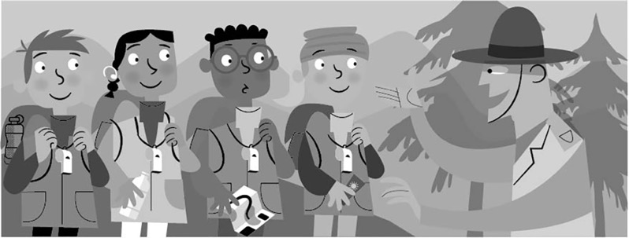

**Reading**

5 Read and complete the sentences with 1, 2, or 3 words.

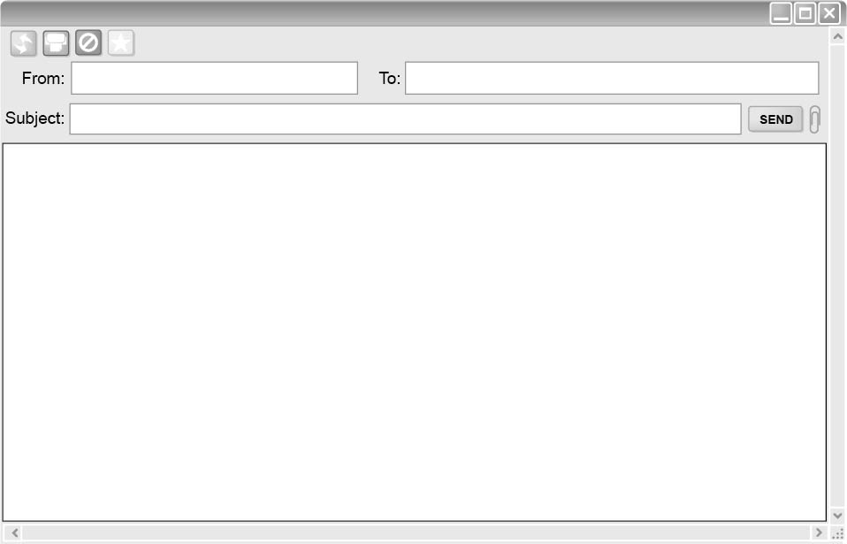

Maria Jodie

Our Camping Trip

Hi Jodie,

I’m really excited about our camping trip next week! You said that this is your first time camping so I want to give you some tips. There are a few things you must bring with you, like a sleeping bag, a flashlight, and a whistle. You don’t have to bring a charger because I have one, and I will also bring the tent. We’ll need gloves if it’s cold in the mornings when we hike. I’ll check the weather forecast and let you know. The plan is to hike to a new camping place every day. If we follow the paths we won’t get lost, but I will take a map, too, so we can walk up the hills and follow the stream. There’s a lot of amazing wildlife near the stream. You’ll love it!

Maria

1 Maria gives Jodie some tips because it’s Jodie’s                                camping.

2 Jodie                                bring a sleeping bag, a flashlight, and a whistle.

3 She                                bring a charger or a tent.

4 If it’s cold in the mornings, they                                            .

5 They                                sleep in the same camping place each day.

     / 5

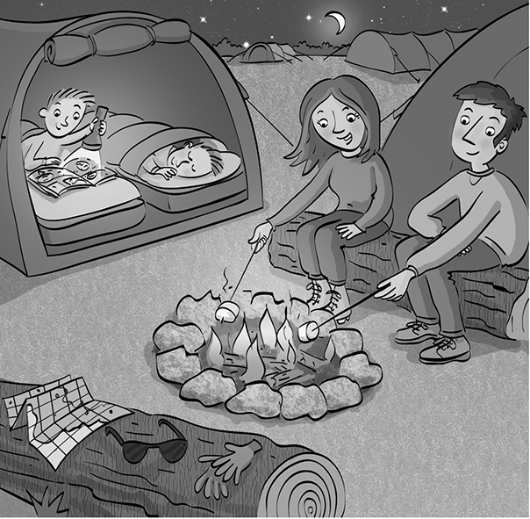

**Writing**

6 Read and complete the story with words from the box.

beautiful boring cold dangerous funny

Last weekend, we went camping. We were tired when we

arrived because we had to spend four hours in the car on

our journey to the park – it was long and very 1                               !

The weather was bad and really 2                      , so my dad made

a fire near our tents. My brother was happy inside his sleeping

bag, and I was using my flashlight to read a book about 3                                snakes.

I was afraid, so Mom started to tell a 4                                story about a time when she

and dad went camping. We laughed a lot! They forgot their tent, so they had to sleep

under the stars. She said the sky was really 5                              !

     / 5

**Listening**

7 Listen. What is each person planning to take? Write the letter.

|  |  |  |  |  |
| --- | --- | --- | --- | --- |
|  |  |  |  |  |
| 1 Amy | 2 Freddy | 3 Hannah | 4 Ted | 5 Martha |

|  |  |  |  |  |
| --- | --- | --- | --- | --- |
|  |  |  |  |  |
| A | B | C | D | E |

     / 5

Unit 8 Test

Vocabulary

**Vocabulary**

1 Read and write the letter.

1 Earth         2 rocket

3 moon         4 telescope

5 astronaut         6 universe

|  |  |  |
| --- | --- | --- |
|  |  |  |
| A | B | C |
|  |  |  |
| D | E | F |

     / 6

2 Choose words from the box to complete the sentences.

crew oxygen planet solar system space station

1 Jupiter is a                                                        .

2 The                                                        is the team who fly a rocket.

3 You need                                                        to breathe in space.

4 A                                                        is a place of work for astronauts.

5 The sun is part of the                                                        .

     / 5

**Grammar**

3 Read and choose A or B.

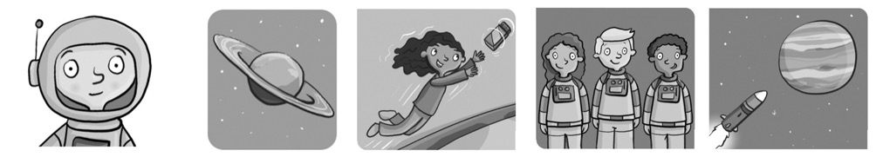

1 She … an astronaut because she’s wearing a space suit.

A ☐ can’t be B ☐ must be

2 That planet … Earth because it has rings.

A ☐ could be B ☐ can’t be

3 When I’m older, I … to space.

A ☐ might travel B ☐ can’t travel

4 Astronauts … if there is no oxygen.

A ☐ must breathe B ☐ can’t breathe

5 We … many more planets and stars in the future.

A ☐ may discover B ☐ can’t discover

     / 5

4 Read and circle the correct relative pronoun.

1 A crew is a group of astronauts **which** / **that** flies rockets into space.

2 A space station is a place **where** / **that** astronauts live and work in space.

3 Saturn is a planet **that** / **who** has rings.

4 Neil Armstrong was the first astronaut **who** / **which** landed on the moon.

5 An observatory is a place **where** / **that** scientists can study constellations in space.

     / 5

**Reading**

5 Read and circle T (true) or F (false).

Chris Hi, Mom! We watched a movie about space travel today. We saw a rocket launch.   
It orbited the Earth and we saw it fly into space before it landed. It was amazing!

Mom Where did it land? Did it land on another planet?

Chris First, it landed on a space station. After that, some of the crew went to the moon.

Mom Wow, that must be fun and interesting, too.

Chris Yes, but an astronaut’s job is difficult. There’s no gravity up there, so when the crew is in the space station, they fly around. Also, when there was a problem with an engine, they didn’t come back to Earth. One of the astronauts had to repair it   
in space!

1 The rocket went around the Earth. T / F

2 The rocket landed on the moon first. T / F

3 All of the astronauts went to the moon. T / F

4 Chris doesn’t think an astronaut’s job is easy. T / F

5 They returned to Earth to repair the engine. T / F

     / 5

**Writing**

6 Look, read, and choose A, B, or C.

**Students in Space**

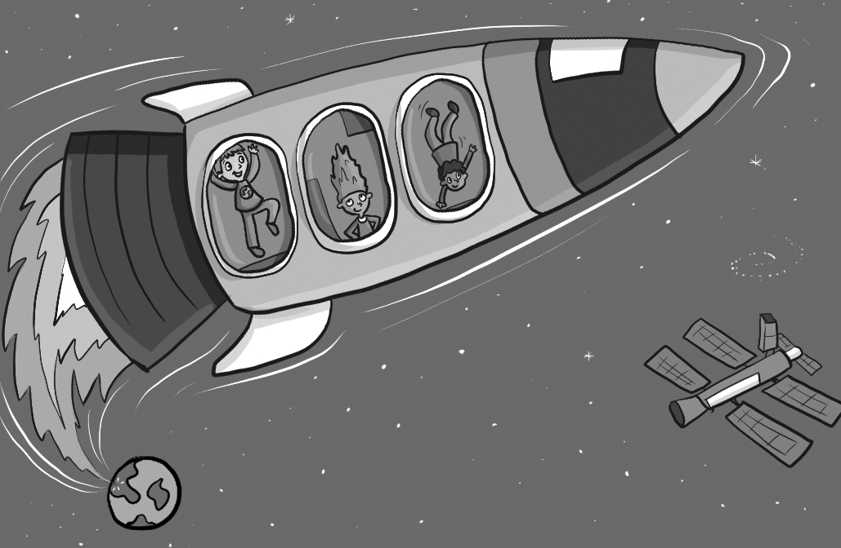

These are the three student astronauts 1       will   
fly into space on *Lunar 1* tomorrow. The rocket   
has a new engine 2       is very big. The engine   
needs a lot of fuel; it 3       very strong and powerful   
to fly into space. The crew will launch the rocket   
into space, 4       it will orbit the Earth three times   
for the crew to take photos of our planet. The astronauts will then land on the space station. Because there is no gravity, it is difficult for the astronauts to eat on the space station. *Lunar 1* is the first rocket 5       will fly to Jupiter before the astronauts come back to Earth.

1 A ☐ which B ☐ who C ☐ where

2 A ☐ who B ☐ where C ☐ that

3 A ☐ must be B ☐ can’t be C ☐ may be

4 A ☐ where B ☐ who C ☐ which

5 A ☐ who B ☐ that C ☐ where

     / 5

**Listening**

8 Listen and and circle T (true) or F (false).

|  |  |  |
| --- | --- | --- |
|  |  |  |
| 1 T / F | 2 T / F | 3 T / F |
|  |  |  |
| 4 T / F | 5 T / F |  |

     / 5

**Grammar**

# Read the sentences and choose A, B, or C.

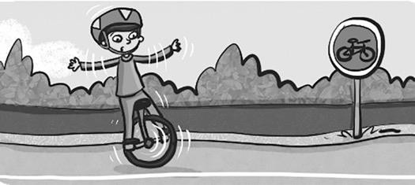

* 1. Have you … a unicycle?

A ☐ ever ridden B ☐ ever ride C ☐ rode

* 1. They have … on a plane before now.

A ☐ never fly B ☐ never flown C ☐ ever fly

* 1. Has she … her passport at home?

A ☐ ever leave B ☐ leave C ☐ ever left

* 1. I have … to Paris.

A ☐ ever be B ☐ ever been C ☐ never been

* 1. He has … late at school.

A ☐ never arrive B ☐ never arrived C ☐ ever arrived

**Writing**

**/10 points**

**6. Read the questions and write your own answers. Freddy** Where do you live?

## You 1

**Freddy** How long have you lived there?

## You 2

**Freddy** What places can you visit there?

## You 3

**Freddy** How do you get to your school?

## You 4

**Freddy** Have you ever lived in another area?

**You** 5

**/ 10 points**

**Reading**

# 5 Read the interview and choose A, B, or C.

Katy: How long have you lived in Manchester? Jay: I’ve lived here 1 … a year.

Katy: What do you like about this city?

Jay: It’s really modern, but it has a great history, too. There’s 2 … an airport here for more than 80 years and there’s a museum that has been here 3 … 1867!

Katy: Have you ever been to the museum? Jay: No, I’ve 4 … been there, but I want to!

Katy: Is there anything you don’t like about the city?

Jay: Well, it’s very busy and there are 5 … downtown all the time. Especially on the weekends!

Katy: Will you live in a village in the country in the future? Jay: No, I don’t want to move! I love it here!

People of Manchester

1. A ☐ since B ☐ for C ☐ ago
2. A ☐ for B ☐ since C ☐ been
3. A ☐ since B ☐ in C ☐ for
4. A ☐ ever B ☐ never C ☐ haven’t
5. A ☐ airport B ☐ crowds C ☐ gas station

**/ 5 points**

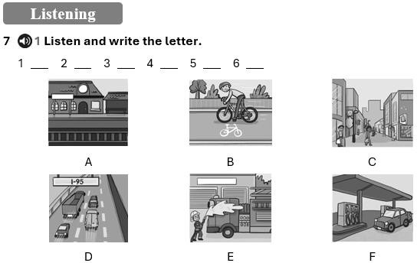

**/ 5 points**

**TOTAL POINTS 50**